Standard 3.1- Vocabulary-The student will develop and expand knowledge of words and word meanings to increase vocabulary-Words in Context-Expand vocabulary in language and writing by reading and listening to a variety of text and literature
Topic: Vocabulary
Grade: 2
Score 4.0  Exceptional | In addition to Score 3.0, in-depth inferences and applications that go beyond what was taught.  The student will construct a sentence that appropriately uses the new vocabulary. | Sample Activities
 |  | - Have students create a yearlong vocabulary book. During each Treasures’ unit, when new vocabulary is introduced, students can record sentences in their vocabulary book. 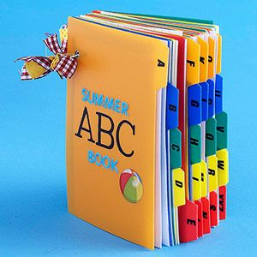
Score 3.0  Capable | The student will be able to:  - (Identify Words in Context)Expand vocabulary in language and writing by reading and listening to a variety of text and literature  The student exhibits no major errors or omissions. | - (Treasures Vocabulary PowerPoints) http://buckwildlearning.weebly.com/2nd.html  - Have students work in small groups while reading the Treasures’ passage for the week. Assign each group a word have them create a definition, sentence, and picture for the word on a large notecard. Then, have students present their word to the class.
Score 2.0  Emerging | There are no major errors or omissions regarding the simpler details and processes as the student:  - performs basic processes, such as:  - with assistance, interpret new vocabulary in a given sentence  - with assistance, recite the meaning of new vocabulary  However, the student exhibits major errors or omissions regarding the more complex ideas and processes. | - (Frayer Model Vocabulary Graphic Organizer) http://www.teacherspayteachers.com/Product/Vocabulary-Frayer-Model-234036
Score 1.0  Beginning | With help, a partial understanding of some of the simpler details and processes and some of the more complex ideas and processes.  The student needs foundational skill help in retaining new vocabulary. | - Provide students with visual cues for new vocabulary words.  - Act out the new vocabulary words.

Standard 2.1c Phonics/Decoding-The student will apply sound-symbol relationships to decode unknown words-Phonetic Analysis-Use blends, digraphs, and diphthongs
Topic: Phonics/Decoding
Grade: 2
Score 4.0  Exceptional | In addition to Score 3.0, in-depth inferences and applications that go beyond what was taught.  The student will apply known phonics concepts to correctly spell unknown words with blends, digraphs, and diphthongs. | Sample Activities
 |  | - Spelling Races- Place different words that contain blends, diagraphs, and diphthongs in a bag, pull out a word, read it, and have students race to spell it.
Score 3.0  Capable | The student will:  - (Phonetic Analysis)Use blends, digraphs, and diphthongs  The student exhibits no major errors or omissions. | - (Notebook presentation- can be used of whole group of centers)  - (Kinesthetic Phonics Activity) http://shshshletthebabysleep.blogspot.com/2011/08/have-fun-with-consonant-blends.html
Score 2.0  Emerging | There are no major errors or omissions regarding the simpler details and processes as the student:  - performs basic processes, such as:  - categorize sets of words with the same blends, diagraphs, and diphthongs  - with assistance, identify patterns in words with blends, digraphs, and diphthongs  However, the student exhibits major errors or omissions regarding the more complex ideas and processes. | - (West Virginia Phonics) https://sites.google.com/a/wvde.k12.wv.us/reading-first-information/phonics-lessons  - (Flashcards) http://www.teacherspayteachers.com/Product/Flash-Cards-blends-digraphs-and-diphthongs-568924
Score 1.0  Beginning | With help, a partial understanding of some of the simpler details and processes and some of the more complex ideas and processes.  The student needs foundational skill help in connecting sounds to symbols. | - (West Virginia Phonics) https://sites.google.com/a/wvde.k12.wv.us/reading-first-information/phonics-lessons  - (Feeding the Cookie Monster- sort activity) http://thefirstgradeparade.blogspot.com/2011/04/cookie-monster-bagpack.html

Standard 5.5b Comprehension/Critical Literacy- The student will interact with the words and concepts in a text to construct an appropriate meaning-Monitoring and Correction Strategies-Integrate the use of semantics, syntax, and graphophonic cues to gain meaning from text.
Topic: Comprehension/Critical Literacy
Grade: 2
Score 4.0  Exceptional | In addition to Score 3.0, in-depth inferences and applications that go beyond what was taught.  The student will analyze figurative language to gain meaning from a text. | Sample Activities
Score 3.0  Capable | The student will:  - (Monitoring and Correction Strategies)-Integrate the use of semantics, syntax, and graphophonic cues to gain meaning from text  - The student will be able to self-correct with reading by determining, if the word makes sense, sounds right, and/or looks right.  The student exhibits no major errors or omissions. | - List Treasures and Center Activities
Score 2.0  Emerging | There are no major errors or omissions regarding the simpler details and processes as the student:  - performs basic processes, such as:  - correct reading mistakes with help and support  However, the student exhibits major errors or omissions regarding the more complex ideas and processes.
Score 1.0  Beginning | With help, a partial understanding of some of the simpler details and processes and some of the more complex ideas and processes.  The student needs foundational skill help in text structure to understand reading.

Standard 4.3 Fluency-The student will identify words rapidly so that attention is directed at the meaning of the text-Engage in repeated readings of the same text to increase fluency
Topic: Fluency
Grade: 2
Score 4.0  Exceptional | In addition to Score 3.0, in-depth inferences and applications that go beyond what was taught.  The student will demonstrate fluency in a new passage that uses previously learned words. | Sample Activities
- Guided Reading Groups
- Timed Fluency Game- create sets of word or sentences. Students read the sentences while being timed. Each day they try to beat their time from the previous day.
Score 3.0  Capable | The student will:  - Engage in repeated reading of the same text to increase fluency  The student exhibits no major errors or omissions. | - Guided Reading Groups  - (Rock Star Fluency Center) http://thefirstgradeparade.blogspot.com.au/2014/07/christmas-in-july.html
Score 2.0  Emerging | There are no major errors or omissions regarding the simpler details and processes as the student:  - performs basic processes, such as:  - recognize words in a familiar order but cannot read every word automatically  - sounds out words in repeated readings  However, the student exhibits major errors or omissions regarding the more complex ideas and processes. | - Guided Reading Groups  - (Fluency Strips) http://moffattgirls.blogspot.com/2014/08/building-fluency-quick-and-easy-way.html  - (Whisper Reader Center) http://www.coffeecupsandcrayons.com/practice-reading-with-a-whisper-reader/
Score 1.0  Beginning | With help, a partial understanding of some of the simpler details and processes and some of the more complex ideas and processes.  The student needs foundational skill support in recognizing sight words. | - Guided Reading Groups  - (Fluency Strips) http://moffattgirls.blogspot.com/2014/08/building-fluency-quick-and-easy-way.html  - Follow along while listening to audio books.

Standard 5.4b Comprehension/Critical Literacy-The student will interact with the words and concepts in a text to construct an appropriate meaning-Analysis and Evaluation-Make comparisons and draw conclusions based on what is read
Topic: Comprehension/Critical Literacy
Grade: 2
Score 4.0  Exceptional | In addition to Score 3.0, in-depth inferences and applications that go beyond what was taught.  The student will prove their inferences by using evidence from the text. | Sample Activities
 |  | - Students list their inferences and then find the parts of the text that supports their thinking (can list the page number or quote the text.)
Score 3.0  Capable | The student will:  - (Analysis and Evaluation)-Make comparisons and draw conclusions based on what is read  The student exhibits no major errors or omissions. | - (Making Inferences) http://thankgoditsfirstgrade.blogspot.com/2014/07/making-inferences-lessons-and-some.html  - (Inference Bags) http://amazingclassroom.blogspot.com/2012/01/inference-bags.html
Score 2.0  Emerging | There are no major errors or omissions regarding the simpler details and processes as the student:  - performs basic processes, such as:  - identify the events of a story and draw conclusions with assistance  - make comparisons in a text with assistance  However, the student exhibits major errors or omissions regarding the more complex ideas and processes. | - (Inference Picture Cards) http://www.teacherspayteachers.com/Product/Inference-Carousel-Making-Inferences-with-Pictures-518792
Score 1.0  Beginning | With help, a partial understanding of some of the simpler details and processes and some of the more complex ideas and processes.  The student needs foundational skill support in making summarizing strategies. | - (Youtube Video to Make Inferences) https://www.youtube.com/watch?v=oIlIVFBBbNw&feature=related

Standard 5.4c Comprehension/Critical Literacy- The student will interact with the words and concepts in a text to construct an appropriate meaning-Analysis and Evaluation-Describe character traits, changes, and relationships
Topic: Comprehension/Critical Literacy
Grade: 2
Score 4.0  Exceptional | In addition to Score 3.0, in-depth inferences and applications that go beyond what was taught.  The student will synthesize why character trait changes affect the plot of a text. | Sample Activities
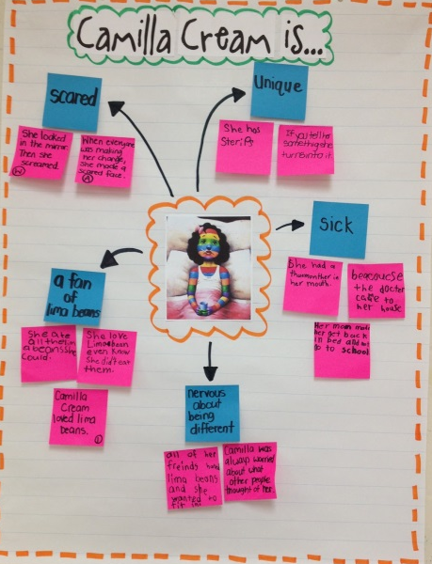
- A Bad Case of Stripes- students identify the character traits of Camila and how her changes throughout the story affect the plot.
Score 3.0  Capable | The student:  - Analysis and Evaluation-Describe character traits, changes, and relationships  The student exhibits no major errors or omissions. | - (What does the text say? Activities http://www.teacherspayteachers.com/Product/What-Does-the-Text-Say-1085248  - Compare Lilly and Wendell (Lilly’s Purple Plastic Purse and Windbell, both by Kevin Henkes)  - (List of Character Traits) http://workshopclassroom.blogspot.com/2013/08/teaching-about-character-traits.html
Score 2.0  Emerging | There are no major errors or omissions regarding the simpler details and processes as the student:  - performs basic processes, such as:  - identify the character traits of the main characters in a text  - explain the cause and effect of character relationships with assistance  - identify changes in characters traits for the main characters in a text  However, the student exhibits major errors or omissions regarding the more complex ideas and processes. | - (Personal Character Traits) http://www.scholastic.com/teachers/top-teaching/2012/11/teaching-character-traits-readers-workshop#.UMsWvXQTVOQ.pinterest
Score 1.0  Beginning | With help, a partial understanding of some of the simpler details and processes and some of the more complex ideas and processes.  The student needs foundational skill support in recognizing character traits. | - (What’s on the inside vs. the outside) http://acrossthehallin2nd.blogspot.com/2013/09/this-funny-thing-happenedi-finally.html

Standard 2.2 b Phonics/Decoding- The student will apply sound-symbol relationships to decode unknown words-Structural Analysis-Apply knowledge of basic syllabication to decode words in text
Topic: Phonics/Decoding
Grade: 2
Score 4.0  Exceptional | In addition to Score 3.0, in-depth inferences and applications that go beyond what was taught.  The students will decode multi-syllabic words in a text. | Sample Activities
- Horton Hears a Who- syllable counting and sorting
http://www.teacherspayteachers.com/Product/Dr-Seuss-Horton-Syllable-Sort-Recording-Sheet-1138726
Score 3.0  Capable | The student will:  - (Structural Analysis)Apply Knowledge of basic syllabication to decode words in text  The student exhibits no major errors or omissions. | - (Syllable Center) http://www.smekenseducation.com/hands-on-fun-with-syllables.html
Score 2.0  Emerging | There are no major errors or omissions regarding the simpler details and processes as the student:  - performs basic processes, such as:  - count syllables in a word, but still struggle to decode  - categorize words with the same number of syllables  However, the student exhibits major errors or omissions regarding the more complex ideas and processes. | - (Syllable Center) http://conversationsinliteracy.blogspot.com/search?q=syllable  - (iPad App) http://conversationsinliteracy.blogspot.com/2014/02/popplet-and-pizza.html
Score 1.0  Beginning | With help, a partial understanding of some of the simpler details and processes and some of the more complex ideas and processes.  The student needs foundational skill support in understanding syllabication. | - (Lego Syllables) http://thisreadingmama.com/counting-syllables-lego-bricks/  - (Syllables with Names) http://www.prekinders.com/teach-syllables/

Standard 4.5 Fluency-The student will identify words rapidly so that attention is directed at the meaning of the text-Use punctuation cues in text (i.e. commas, periods, question marks, and exclamation points) as a guide to understanding meaning
Topic: Fluency
Grade: 2
Score 4.0  Exceptional | In addition to Score 3.0, in-depth inferences and applications that go beyond what was taught.  The student will be able to analyze why the author chose to use a certain type to punctuation and what point the author was trying to make. | Sample Activities
- Pigeon books by Mo Williams to determine purpose of punctuation
http://thefabulousfirstgrade-sarah.blogspot.com/2012/10/crazy-about-punctuation-freebies-galore.html
Score 3.0  Capable | The student will:  - Use punctuation cues in text (i.e. commas, periods, question marks, and exclamation points) as a guide to understanding meaning  The student exhibits no major errors or omissions. | - Kinesthetic Punctuation:  Teacher- Read a sentence and inflect voice depending on the punctuation that should be used  Student- After the sentence has been read the students decide what punctuation should be used by acting it out with their bodies  Period: crouch down in a ball  Exclamation: stand up tall with arms straight in the air next to head  Question Mark: stand up and bend over slightly with arms in the air and arched over
Score 2.0  Emerging | There are no major errors or omissions regarding the simpler details and processes as the student:  - performs basic processes, such as:  - identify punctuation in a sentence  - classify what different punctuation marks mean  However, the student exhibits major errors or omissions regarding the more complex ideas and processes. | - (Punctuation Stop Light) http://www.learningunlimitedllc.com/2013/09/freddy-fluency-a-fluency-tool-for-primary-students/
Score 1.0  Beginning | With help, a partial understanding of some of the simpler details and processes and some of the more complex ideas and processes.  The student needs foundational skill support in punctuation. | - (Punctuation Sentence Strips) http://rowdyinroom300.blogspot.com/2014/04/hi-friends-weve-been-working-really.html

Standard 5.1b Comprehension/Critical Literacy- The student will interact with the words and concepts in a text to construct an appropriate meaning-Literal Understanding-Use pre-reading strategies to preview, activate prior knowledge, make predictions, use picture clues, and establish the purpose for reading (i.e. graphic organizers)
Topic: Comprehension/Critical Literacy
Grade: 2
Score 4.0  Exceptional | In addition to Score 3.0, in-depth inferences and applications that go beyond what was taught.  The student will be able to analyze their prediction after reading the text to determine how accurate their thinking was. | Sample Activities
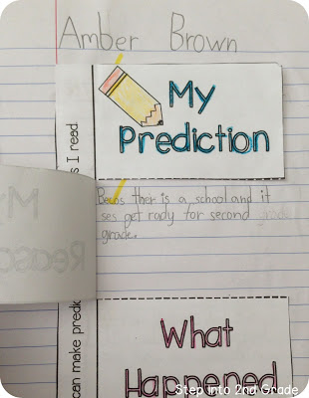
- (Interactive Notebook Predictions)- Write the prediction, list the reason, write what actually happened, go back and compare how close the prediction was.
Score 3.0  Capable | The student will:  - (Literal Understanding)Use pre-reading strategies to preview, activate prior knowledge, make predictions, use picture clues, and establish the purpose for reading (i.e. graphic organizers)  The student exhibits no major errors or omissions. | - Use science experiments to make predictions about what will happen (i.e. What will happen with you give a plant water and when you don’t)  - Make predictions in a Scholastic News magazine and label the features used to make the predictions  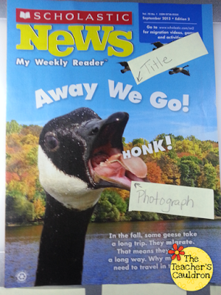  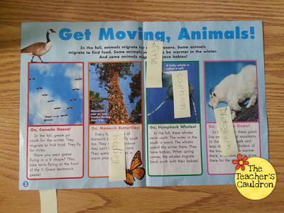
Score 2.0  Emerging | There are no major errors or omissions regarding the simpler details and processes as the student:  - performs basic processes, such as:  - identify different text features  - interpret the usage of different text features with assistance  - use text features to make a prediction; although the prediction may not be appropriately aligned to the text  However, the student exhibits major errors or omissions regarding the more complex ideas and processes. | 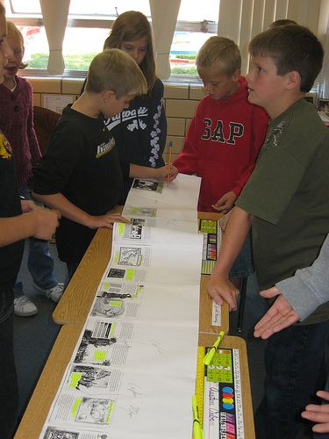  - Text Feature Scavenger Hunt- look for different text features, list them, define their purpose.
Score 1.0  Beginning | With help, a partial understanding of some of the simpler details and processes and some of the more complex ideas and processes.  The student needs foundational skill support in text features. | 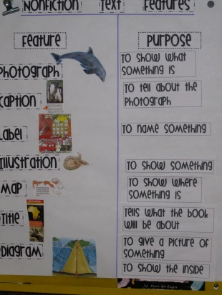  - Non-fiction text feature anchor chart
Standard 7.2 Research and Information- The student will conduct research and organize information-Interpreting Information-Analyze and evaluate information from a variety of sources
Topic: Research and Information
Grade: 2
Score 4.0  Exceptional | In addition to Score 3.0, in-depth inferences and applications that go beyond what was taught.  The student will be able to critique information from a variety of sources and determine what other research needs to be conducted. |  | Sample Activities
Score 3.0  Capable | The student will:  - (Interpreting Information)-Analyze and evaluate information from a variety of sources  The student exhibits no major errors or omissions. |  | - List Treasures and Center Activities
Score 2.0  Emerging | There are no major errors or omissions regarding the simpler details and processes as the student:  - performs basic processes, such as:  - interpret information from a variety of sources  - summarize information for a variety of sources  - analyze information from a variety of sources with assistance  However, the student exhibits major errors or omissions regarding the more complex ideas and processes.
Score 1.0  Beginning | With help, a partial understanding of some of the simpler details and processes and some of the more complex ideas and processes.  The student needs foundational skill support in interpreting information.

Standard 5.3 Comprehension/Critical Literacy-The student will interact with the words and concepts in a text to construct an appropriate meaning-Summary and Generalization-Retell or act out narrative text by identifying story elements and sequencing the events
Topic: Comprehension/Critical Literacy
Grade: 2
Score 4.0  Exceptional | In addition to Score 3.0, in-depth inferences and applications that go beyond what was taught.  The student will be able to create their own ending to a story and explain how their ending affects the sequence of events. | Sample Activities
 |  | Students can listen to or read a famous fairytale. Then, students can create their own ending through writing or recording and share with the class how their ending affected the sequence of events.
Score 3.0  Capable | The student will:  - (Summary and Generalization)Retell or act out narrative text by identifying story elements and sequencing the events  The student exhibits no major errors or omissions. | - (The Little Red Hen) http://www.teacherspayteachers.com/Product/Little-Red-Hen-Story-Sequence-and-Acting-Out-1488418  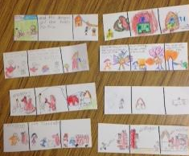  - Comic Strip Plots- read a story, have students retell the story by making it a comic strip, then have students use the pictures to help them verbally retell the story
Score 2.0  Emerging | There are no major errors or omissions regarding the simpler details and processes as the student:  - performs basic processes, such as:  - sequencing events of a text with prompting  - identify story elements with support  However, the student exhibits major errors or omissions regarding the more complex ideas and processes. | - Create a story path where students walk along the path to retell the sequence of evets. Picture can be provided along the path to provide students with visual reminders. 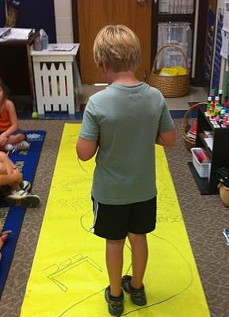
Score 1.0  Beginning | With help, a partial understanding of some of the simpler details and processes and some of the more complex ideas and processes.  The student needs foundational skill support in summarizing strategies. | 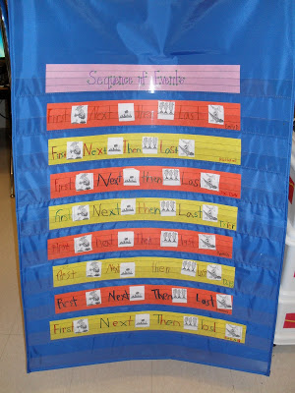  - Practice using order words and pictures tot sequence events (first, next, then, last)

Standard 5.1c Comprehension/Critical Literacy-The student will interact with the words and concepts in a text to construct an appropriate meaning-Literal Understanding-Ask and respond to questions to aid comprehension about important elements of fiction and nonfiction

Topic: Comprehension/Critical Literacy
Grade: 2
Score 4.0  Exceptional | In addition to Score 3.0, in-depth inferences and applications that go beyond what was taught.  The student will be able to ask and respond to questions that connect fiction and nonfiction text | Sample Activities
- Compare the elements of fiction and non-fiction
http://shenanigansinsecond.blogspot.com/2011/11/were-all-jacked-up-on-nonfiction.html
Score 3.0  Capable | The student will:  - (Literal Understanding)Ask and respond to questions to aid comprehension about important elements of fiction and nonfiction  The student exhibits no major errors or omissions. | - (How to use the Scholastic Weekly Reader and implement comprehension strategies) http://www.weeklyreader.com/article/top-tips-teaching-reading-comprehension/
Score 2.0  Emerging | There are no major errors or omissions regarding the simpler details and processes as the student:  - performs basic processes, such as:  - respond to comprehension questions about main idea and details; however answers may not be completely correct  - ask questions about a text; however questions may lack importance to understanding comprehension elements  However, the student exhibits major errors or omissions regarding the more complex ideas and processes. | - (Helping students remember parts of a story) http://www.scholastic.com/parents/blogs/scholastic-parents-raise-reader/what-to-do-when-your-child-cant-remember-what-he-reads
Score 1.0  Beginning | With help, a partial understanding of some of the simpler details and processes and some of the more complex ideas and processes.  The student needs foundational support in story elements. | - (Variety of books to teach and show how to use different comprehension strategies) http://www.mauryk12.org/Literacy/reading%20mentor%20texts.htm

Standard 3.2 Vocabulary-The students will develop and expand knowledge of words and word meanings to increase vocabulary-Synonyms, antonyms, and homonyms/homophones-Understand and explain common antonyms, synonyms, and homonyms/homophones
Topic: Vocabulary
Grade: 2
Score 4.0  Exceptional | In addition to Score 3.0, in-depth inferences and applications that go beyond what was taught.  The student will be able to create their own antonyms, synonyms, and homonyms/homophones. | Sample Activities
- Come up with new words to replace “boring words” on the word wall
http://www.mpmschoolsupplies.com/ideas/1084/rescue-tired-words-interactive-classroom-word-wall/
Score 3.0  Capable | The student:  - (Synonyms, antonyms, and homonyms/homophones)Understand and explain common antonyms, synonyms, and homonyms/homophones  The student exhibits no major errors or omissions. | - (Interactive Notebook Page) http://ilove2teach.blogspot.com/2013/04/prefix-suffix-foldable-freebie.html?m=1
Score 2.0  Emerging | There are no major errors or omissions regarding the simpler details and processes as the student:  - performs basic processes, such as:  - sort words that mean the same thing or are opposites  - identify antonyms, synonyms, and homonyms/homophones, but cannot independently explain them  However, the student exhibits major errors or omissions regarding the more complex ideas and processes. | - Synonym, Antonym, Homophone Sort http://collaborationcuties.blogspot.com/2013/03/eggcellent-word-study-take-it-and-make.html
Score 1.0  Beginning | With help, a partial understanding of some of the simpler details and processes and some of the more complex ideas and processes.  The student needs foundational support in word meanings. | - Antonym Picture Cards http://www.teacherspayteachers.com/Product/FREEBIE-Picture-antonym-cards-657588  - Synonym and Antonym Card  http://www.teacherspayteachers.com/Product/Picture-Cards-for-Antonyms-and-Synonyms-423752

Standard 2.2a Phonics/Decoding- The student will apply sound-symbol relationships to decode unknown words- Structural Analysis-Build and understand compound words, contractions, and base words using prefixes and suffixes
Topic: Phonics/Decoding
Grade: 2
Score 4.0  Exceptional | In addition to Score 3.0, in-depth inferences and applications that go beyond what was taught.  The student will analyze how to change word meaning by using compounds, contractions, and prefixes/suffixes. | Sample Activities
- Sort between compound and non-compound words http://www.teacherspayteachers.com/Product/Compound-WordNot-a-Compound-Word-Sort-222224
- Prefixes and Suffixes Meanings
http://www.teacherspayteachers.com/Product/Prefixes-and-Suffixes-Cheat-Sheet-366558
Score 3.0  Capable | The student will:  - (Structural Analysis)Build and understand compound words, contractions, and base words using prefixes and suffixes  The student exhibits no major errors or omissions. | - Compound Words Bundle http://www.teacherspayteachers.com/Product/Compound-Words-MEGA-Pack-762741
Score 2.0  Emerging | There are no major errors or omissions regarding the simpler details and processes as the student:  - performs basic processes, such as:  - group words with common contractions and base words  - identify patterns in compound words, contractions, and prefixes/suffixes with guidance and support  However, the student exhibits major errors or omissions regarding the more complex ideas and processes. | - Compound Words Foldable  http://reliefteachingideas.wordpress.com/2014/04/26/compound-words-foldable/comment-page-1/#comment-624
Score 1.0  Beginning | With help, a partial understanding of some of the simpler details and processes and some of the more complex ideas and processes.  The student needs foundational support in word meaning. | - Compound Words Picture Cards http://www.teacherspayteachers.com/Product/Compound-Words-Literacy-Centres-519654

Standard 5.3b Comprehension/Critical Literacy- The student will interact with the words and concepts in a text to construct an appropriate meaning-Summary and Generalization-Produce oral or written summaries of text selections by discussing who, what, when, where, why, and how to identify the main idea and significant supporting details of a text
Topic: Comprehension/Critical Literacy
Grade: 2
Score 4.0  Exceptional | In addition to Score 3.0, in-depth inferences and applications that go beyond what was taught.  The student will use knowledge of main idea and details to describe and illustrate common themes across texts. | Sample Activities
- Fairytale Comparing Themes
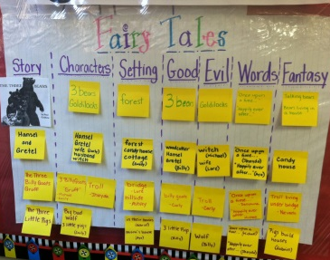
Score 3.0  Capable | The student will:  - (Summary and Generalization)Produce oral or written summaries of text selections by discussing who, what, when, where, why, and how to identify the main idea and significant supporting details of a text  The student exhibits no major errors or omissions. | - 5Ws Bingo  http://www.teacherspayteachers.com/Product/WH-Question-Bingo-Who-What-When-Where-and-Why-1246540
Score 2.0  Emerging | There are no major errors or omissions regarding the simpler details and processes as the student:  - performs basic processes, such as:  - identify who, what, when, where, and why with support  - identify supporting details but have trouble connecting them to the main idea  - identify details but they may not be siginigicant to the story  However, the student exhibits major errors or omissions regarding the more complex ideas and processes. | - 5W’s ball  http://www.coffeecupsandcrayons.com/practice-questioning-with-a-question-ball/
Score 1.0  Beginning | With help, a partial understanding of some of the simpler details and processes and some of the more complex ideas and processes.  The student needs foundational support in story elements. | - Main Idea and Detail Puzzles- use a puzzle to show a main idea all the pieces make up the supporting details

Standard 2.1 Phonics/Decoding-The student will apply sound-symbol relationships to decode unknown words-Phonetic Analysis-Use short, long, and r-controlled vowel sounds
Topic: Phonics/Decoding
Grade: 2
Score 4.0  Exceptional | In addition to Score 3.0, in-depth inferences and applications that go beyond what was taught.  The student will fluently read unfamiliar short, long, and r-controlled vowel sounds. | Sample Activities
 |  | - Students can come up with a list of their own r-controlled vowels http://theinspiredapple.blogspot.com/2011/03/teaching-r-controlled-vowels-ar-first.html
Score 3.0  Capable | The student will:  - (Phonetic Analysis)Use short, long, and r-controlled vowel sounds  The student exhibits no major errors or omissions. | - Vowel Song  https://www.youtube.com/watch?v=fR-BLFZyAWs  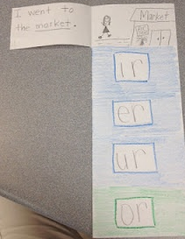  - R-controlled flip book
Score 2.0  Emerging | There are no major errors or omissions regarding the simpler details and processes as the student:  - performs basic processes, such as:  - identify words with short, long, and r-controlled vowel sounds but may not be able to use them independently  - distinguish between short, long, and r-controlled vowel sounds with support  However, the student exhibits major errors or omissions regarding the more complex ideas and processes. | - Long and Short Vowels  http://www.teacherspayteachers.com/Product/Alphabet-Vowel-and-Word-Work-Charts-Free-1030994  - Vowel Flipbook  http://mrsbumgardners1stgradeclass.blogspot.com/2010/10/short-vowel-review-week.html
Score 1.0  Beginning | With help, a partial understanding of some of the simpler details and processes and some of the more complex ideas and processes.  The student needs foundational support in phonics. | - Short Vowel Word Building  http://thisreadingmama.com/free-short-vowel-word-building-pack/

Standard 4.2 Fluency- The student will identify words rapidly so that attention is directed at the meaning of the text-Read regularly in instructional-level text that is challenging yet manageable (texts in which no more than 1 in 10 words is difficult for the reader)
Topic: Fluency
Grade:2
Score 4.0  Exceptional | In addition to Score 3.0, in-depth inferences and applications that go beyond what was taught.  The student will read in a above grade level text in which no more than 1 in 10 words is difficult for the reader. | Sample Activities
- 3rd grade sight words
http://www.schoolsparks.com/blog/keep-on-reading-with-third-grade-sight-words
Score 3.0  Capable | The student will:  - Read regularly in instructional-level text that is challenging yet manageable (texts in which no more than 1 in 10 words is difficult for the reader)  The student exhibits no major errors or omissions. | - 2nd grade sight word sentences  http://www.schoolsparks.com/blog/get-reading-with-sight-word-sentences  - The sight word song  https://www.youtube.com/watch?v=1rmYfo84hyg
Score 2.0  Emerging | There are no major errors or omissions regarding the simpler details and processes as the student:  - performs basic processes, such as:  - more than 1 in 10 words in a grade level text is challenging  However, the student exhibits major errors or omissions regarding the more complex ideas and processes. | - Dolch Word List and Flashcards  http://www.uniqueteachingresources.com/dolch-sight-words.html  - Sight word games  http://www.teacherspayteachers.com/Product/Super-engaging-Superhero-sight-word-activities-670496
Score 1.0  Beginning | With help, a partial understanding of some of the simpler details and processes and some of the more complex ideas and processes.  The student needs foundational skill support in grade level high frequency words and phonics. | - Sight word puzzles  http://www.teachersnotebook.com/product/Curious_Cat_Was_Here/sight-word-puzzles-bundle

Standard 6.1 Literature-The student will read to construct meaning and respond to a wide variety of literary forms-Literary Genres-Demonstrate knowledge of and application for various forms (genres) of literature
Topic: Literature
Grade: 2
Score 4.0  Exceptional | In addition to Score 3.0, in-depth inferences and applications that go beyond what was taught.  The student will be able to synthesize various forms of literature to determine author’s purpose. | Sample Activities
- Author’s Purpose Matching Activity
http://www.teacherspayteachers.com/Product/Authors-Purpose-Cut-and-Paste-Matching-Activity-Assessment-387691
Score 3.0  Capable | The student will:  - (Literary Genres)Demonstrate knowledge of and application for various forms (genres) of literature  - The student will recognize defining characteristics of a variety of texts.  The student exhibits no major errors or omissions. | - Genre Web  http://staudtsmark.blogspot.com/2012/10/genre-webs.html  - Use Scholastic Book Order to separate books by genre and determine their characteristics  http://www.lessonswithlaughter.com/2012/12/genre-posters.html?m=1
Score 2.0  Emerging | There are no major errors or omissions regarding the simpler details and processes as the student:  - performs basic processes, such as:  - classify characteristics in a text with help and support  - determine meaning of a text with help and support  However, the student exhibits major errors or omissions regarding the more complex ideas and processes. | - Genre posters  http://www.teacherspayteachers.com/Product/Genre-Posters-1314706
Score 1.0  Beginning | With help, a partial understanding of some of the simpler details and processes and some of the more complex ideas and processes.  The student needs foundational skill support in text features, understanding of different genres, and comprehension skills. | - Non-fiction book features  https://www.youtube.com/watch/?v=XoudxEM3dRY

